The Ladder of Engagement
Cross Checking Professional Understandings

Once the engagement audits have been conducted, it is essential to keep cross checking professional perceptions of community engagement with community members themselves, to understand whether they share the same perspectives on engagement.
In this way project planning can start to take into account any similarities between professional and community understandings, acknowledge and discuss contrasts in preferred engagement approaches or understandings that emerge, and to find opportunities to query why such similarities and differences may be occurring.

Using the Ladder of Engagement is a helpful tool in beginning this process.
- The activity counteracts a criticism that it remains the professionals themselves who discuss the ladder of participation and debate where work needs to be done on the ladder (Bovaird and Loeffler, 2012).
- After professionals have carried out this activity, stakeholders are asked to place their different engagement experiences on an ‘engagement ladder’.
- The activity is designed so that the participants themselves can discuss and interact with the ladder – and make suggestions for change.
- The activity generates a range of professional and community member responses, with all the associated shared insights and perspectives that this involves and starts the thinking process about what changes in strategy and practice could support more relational approaches.
- The Ladder of Engagement activity explicitly acknowledges the importance of professionals learning from stakeholders, so as to gain a better understanding of the experiences, culture and assets of communities, as well as resources that communities may lack (Warren et al, 2009).

16

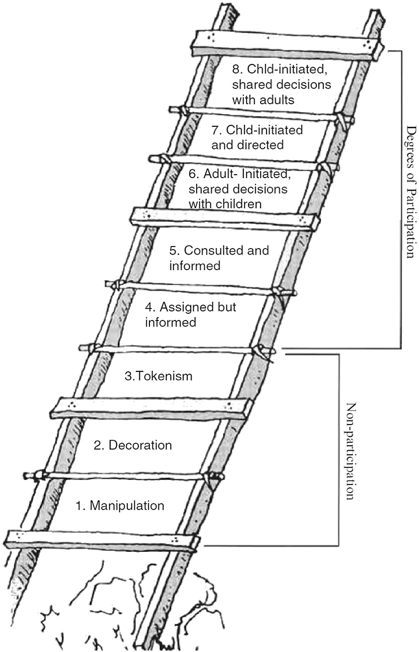
The Ladder of Engagement is adapted from
Hart’s (1992) Ladder of Participation.
In his essay for UNICEF, Children’s Participation: From Tokenism to Citizenship, Hart (1992) adapted Arnstein’s Ladder of Citizen Participation (1969, p.217) “to serve as a beginning typology for thinking about
children’s participation in projects” (p.9).

Activity 4
After conducting an engagement audit, the team invites community members to discuss their experiences of the project process. This can be done in different ways:
In a community space, The Ladder of Engagement can be displayed in a large paper format. Participants can work in small groups to consider their opinions on where different engagement activities (and the different stages of those activities) lie on the Ladder. Post its can be used to write individual comments and reflections, to identify where the project activity/stage of activity appears on the ladder and to discuss the key components that participants think would move future activities towards ‘doing with’ rather than ‘doing to’.
Participants can be asked which policymakers/professionals they would like to work with/get to know, and who the key people are in their community that professionals need to work with/get to know. Participants should have the opportunity to say what information they need from professionals/policymakers and what skills and knowledge they need to develop – and vice versa.
In order to cross-reference thoroughly, questions can be tailored to focus on information from the 3 audits (e.g. asking participants about relational goods such as trust, social influence, emotional support, awareness of community assets etc).
The activity could also be conducted online using a tool such as Padlet etc, with different activities under different tabs.

The activity enables an ongoing comparison of professional and community perceptions and understandings of engagement, and how to move towards a shared understanding of a relational model.

Ladder of Engagement
Equal partners  Stakeholders and the organisation (e.g. the city council) share the decision-making. Stakeholders have the ideas, set up the project and invite the organisation to join in the decision-making. | Doing With  Doing To
Shared decisions
The organisation has the main idea, stakeholders help make decisions, plan and carry out the project.
Consulted
Stakeholders are consulted and informed.

The organisation designs and develops the project but stakeholders’ opinions are taken into account and feedback given.
Assigned
Stakeholders are assigned but informed.
The organisation decides on the project and stakeholders volunteer. Stakeholders understand the project and the organisation respects their views.
Tokenism
Stakeholders have limited voice & choice about what they can say and how they can communicate.
Decoration
Stakeholders take part in an event in a very limited way and have no role in decision-making.
Manipulation
The organisation has complete and unchallenged authority and they use stakeholders’ ideas and choices for their own gain.

Adapted from Hart’s Ladder of Participation (1992)

